DAILY JOURNAL APP
@CREATIVITY THINK (9483175986/7019689991)

ABSTRACT:
The Daily Journal App is a lightweight web application designed for personal journaling and simple day-to-day tracking. Users can write, edit, delete, and search journal entries while viewing basic analytics such as entry counts and simple statistics. Administrators can moderate entries using Django Admin for oversight. Developed using Django for the backend and React with Axios for frontend interactions, the application offers a simple, secure, and efficient platform for maintaining a personal digital journal..

INTRODUCTION OF THE PROJECT:
Many individuals seek an organized method to record daily thoughts, experiences, or personal reflections. Traditional notebooks or scattered digital notes lack searchability and analytics. The Daily Journal App provides a dynamic, digital platform for creating, editing, and reviewing journal entries. Its user-friendly interface allows seamless interaction for personal tracking, while the administrator can ensure content moderation through Django Admin. The system enhances personal organization, tracking habits, and gaining insights from recorded data..

PROJECT OBJECTIVES:

• Enable users to create, edit, and delete journal entries
• Allow users to browse and search previous entries efficiently
• Provide basic analytics such as entry counts and simple statistics
• Offer administrators moderation capabilities via Django Admin
• Ensure a lightweight, user-friendly interface
• Maintain secure and reliable storage of journal entries
• Deliver a simple yet scalable personal journaling solution

PROBLEM OF THE STATEMENT:
Personal journaling often relies on physical notebooks or unorganized digital tools, making it difficult to search or analyze past entries. Users may lose track of their progress or insights over time. Administrators cannot moderate content efficiently without a structured backend. The Daily Journal App addresses these issues by offering a digital journaling platform with search, analytics, and administrative oversight, enhancing organization, accessibility, and user experience..

MOTIVATION OF THE PROJECT:
• To provide a simple, digital alternative to paper journaling
• To enable easy searching and tracking of daily entries
• To give users basic analytics for reflection and insight
• To allow administrators to moderate entries efficiently
• To improve organization and digital habit tracking
• To deliver a lightweight and low-cost journaling solution

BLOCK DAIGRAM OF PROJECT:

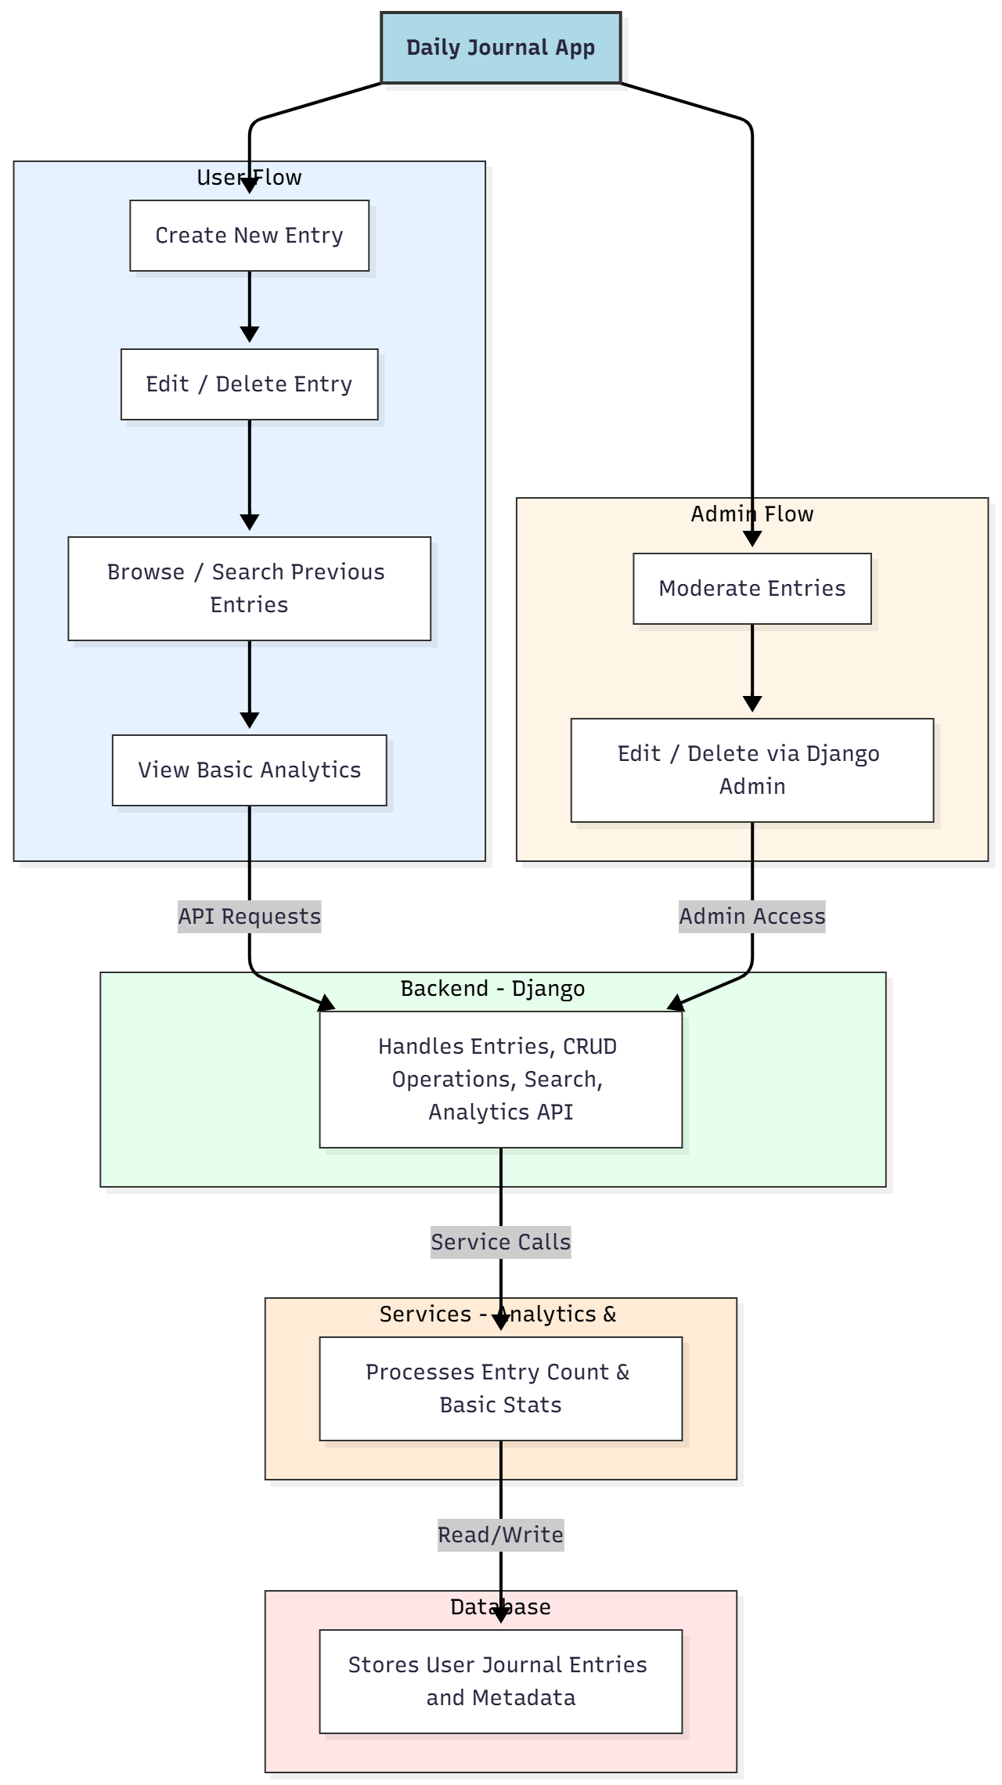

WORKING OF THE PROJECT:
Users can create, edit, and delete journal entries dynamically. Entries are stored securely in the backend database managed by Django. Users can search and browse previous entries efficiently and view simple analytics such as entry counts or daily summaries. Administrators can moderate entries via Django Admin, editing or deleting content if required. The backend handles all CRUD operations, search functionality, and analytics processing to ensure a smooth and reliable journaling experience..

SOFTWARE REQUIREMENT:
- Backend:
  - Python 3.x
  - Django
  - Django REST Framework
  - SQLite/PostgreSQL
- Frontend:
  - Node.js and npm
  - React.js
  - Axios
- Development Tools:
  - Visual Studio Code
  - Postman (for testing APIs)
  - Git/GitHub (for version control)
- Server/Deployment (Optional):
  - Gunicorn, Nginx, or Heroku/AWS for hosting

ADVANTAGES OF THE PROJECT:

• Lightweight and easy-to-use journaling platform
• Searchable entries for quick retrieval
• Basic analytics to track journaling habits
• Administrative moderation via Django Admin
• Dynamic and responsive interface
• Low development and delivery cost
• Suitable for students and individual users

APPLICATIONS OF THE PROJECT:
• Personal journaling
• Daily mood or habit tracking
• Student note-taking
• Simple personal analytics for entries
• Basic lifestyle tracking

REFERENCES:

- Django REST Framework Documentation — Django Software Foundation. Django Documentation. Available: https://docs.djangoproject.com/
- Django REST Framework. DRF Documentation. Available: https://www.django-rest-framework.org/
- React. React Official Documentation. Available: https://reactjs.org/docs/getting-started.html
- Redux. Redux Documentation. Available: https://redux.js.org/introduction/getting-started
- PostgreSQL Global Development Group. PostgreSQL Documentation. Available: https://www.postgresql.org/docs/
- MySQL. MySQL Reference Manual. Available: https://dev.mysql.com/doc/
- Git. Git Documentation. Available: https://git-scm.com/doc
- Node.js. Node.js Documentation. Available: https://nodejs.org/en/docs/
- Axios. Axios Documentation. Available: https://axios-http.com/docs/intro
- Socket.io Documentation – https://socket.io/docs/

